# Learning Modules

The Learning modules will be divided into sections similar to the Getting Started module. Listed below is an example of a learning module. The module is from a CSC151 Java Programming class but the same format is used in other programming classes.

**Note**: Some of the headings in your class may be different.

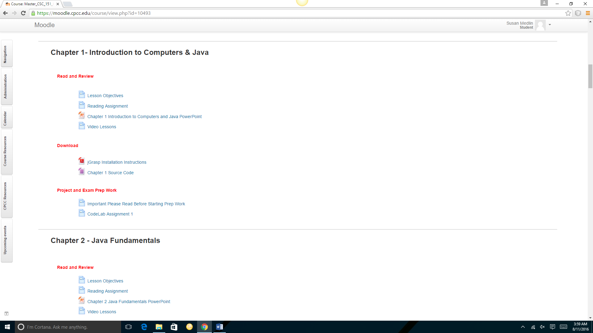

## Read and Review

The Read and Review section will always have the Lesson Objectives for the module. You will also see a reading assignment from your book. **Note:** you should read **only** **what your instructor has assigned for the week.**  Under this section you may also find a PowerPoint file and video lessons.

## Download

Download any documents/files that have been provided by your instructor. You will not be able to complete your assignments if you do not download the resources under this link. Contact your instructor if you need assistance downloading your resources.

## Project/Exam Prep Work

As noted on the syllabus, your course is a PBL (Project Based Learning) course. Under this section you will find weekly assignments that will prepare you for successfully completing your projects and exams. These assignments are **not** submitted for grading, however, you can get assistance with completing the assignments. **Note:** many students fail the course because they do not complete the work under this section.

Your class may have multiple practice assignments. You may, for example, be required to complete programming challenges from your book; participate in a discussion forum or complete practice code snippet assignments (i.e., snippets from a site named CodeLab).

**Note:** If your time is limited, focus your attention primarily on the programming challenges and the discussion forums. Practice the code snippet assignments only if you have additional time in the week.

In this document we will demonstrate how to complete a Programming Challenge assignment. **Note:** Programming Challenges will start in the Chapter 2 module.

1. Under **Project and Exam Prep Work** click the **Chapter 2 Programming Practice** **Assignments** link.

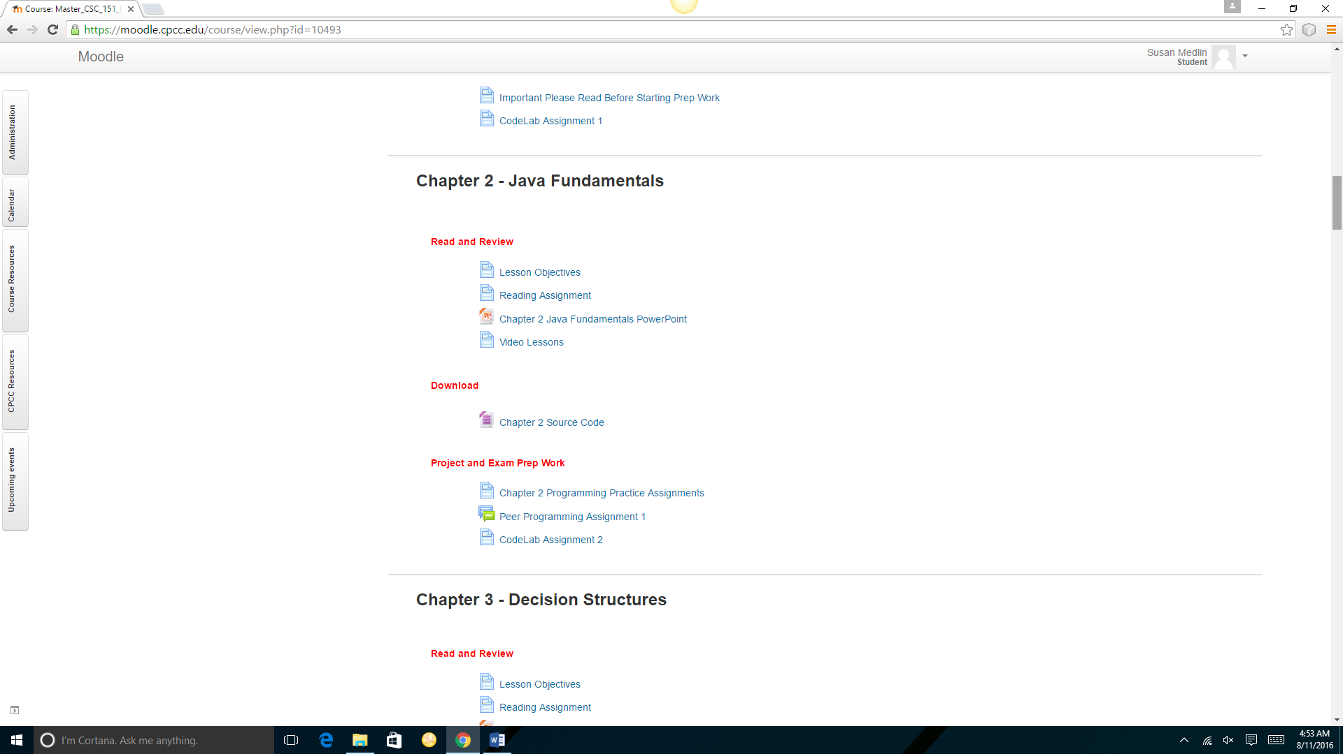

You will see a list of programming challenges.

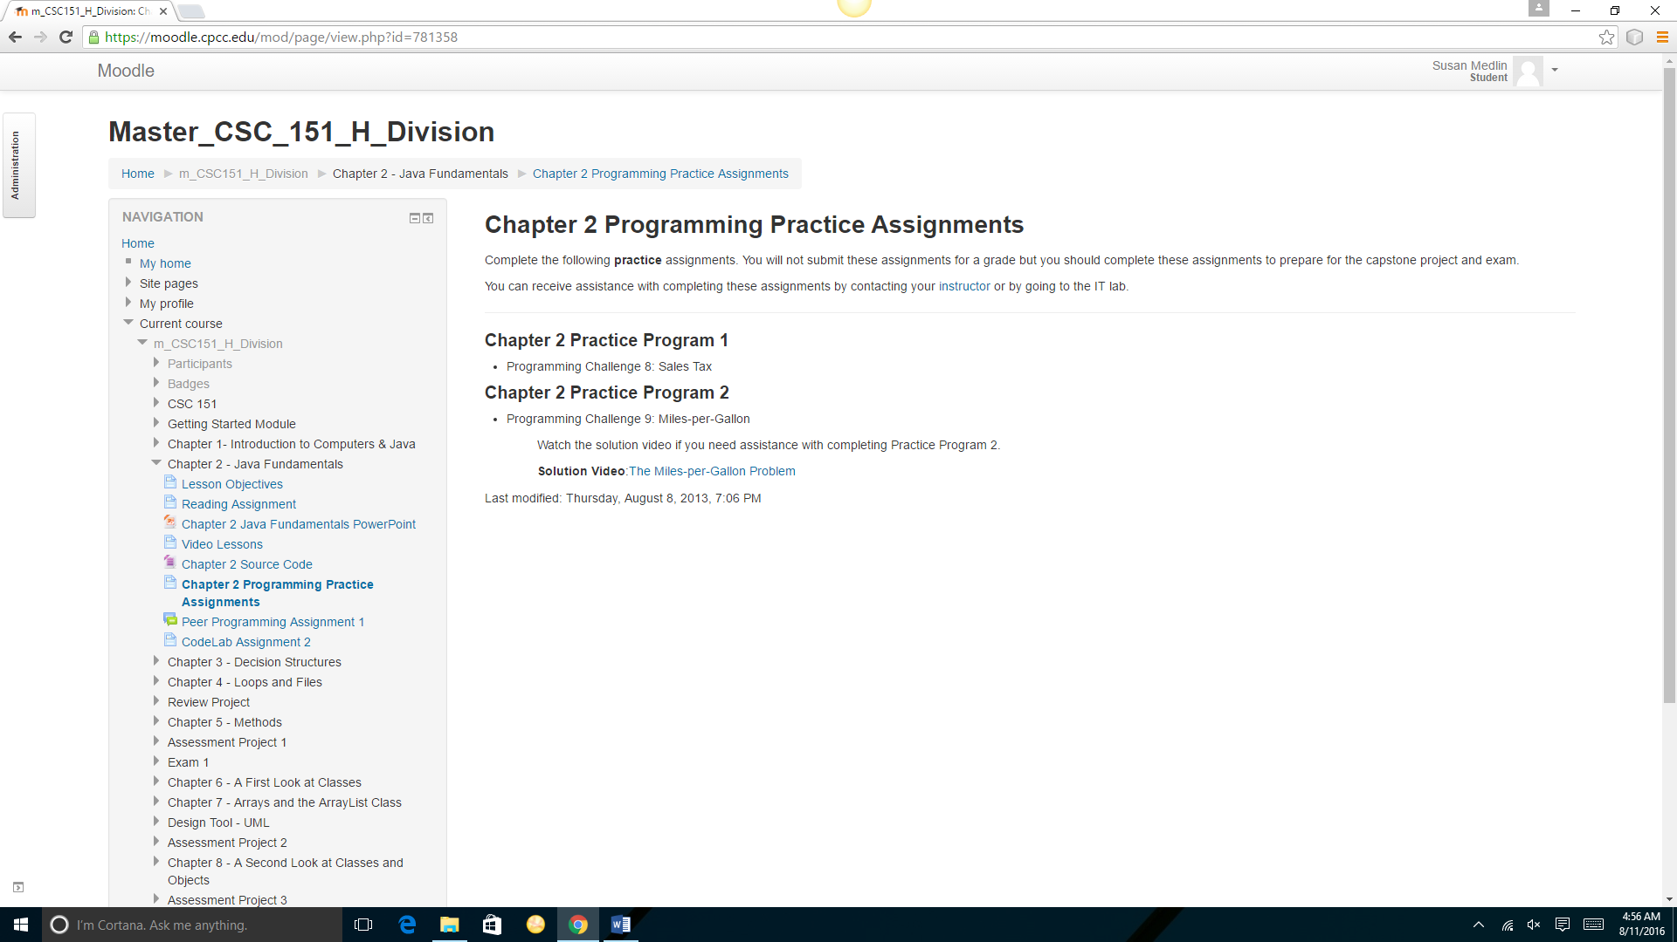

1. Open your book to the Programming Challenges. Programming Challenges are listed at the end of each chapter. In the above assignment, the first assignment is **Programming Challenge 8**. **Note:** You may have a different book version. Look for the name of the assignment if the number is not the same (**example:** Sales Tax is the name of the programming challenge). Follow the instructions in your book to complete the practice assignment.

Contact your instructor if you need assistance completing the assignments. You can also get assistance in the lab. The lab location is located on the Moodle homepage.

## Complete and Submit

Under the Complete and Submit heading you will find links to quizzes and/or project submission links. Click the links and follow the instructions for completing a quiz or uploading an assignment. Remember to follow the due dates listed on the Due Date Calendar.